1.2.1

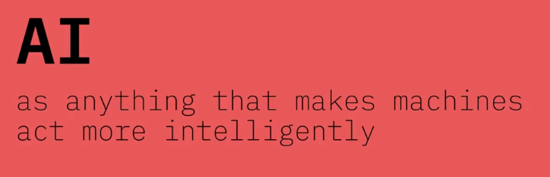

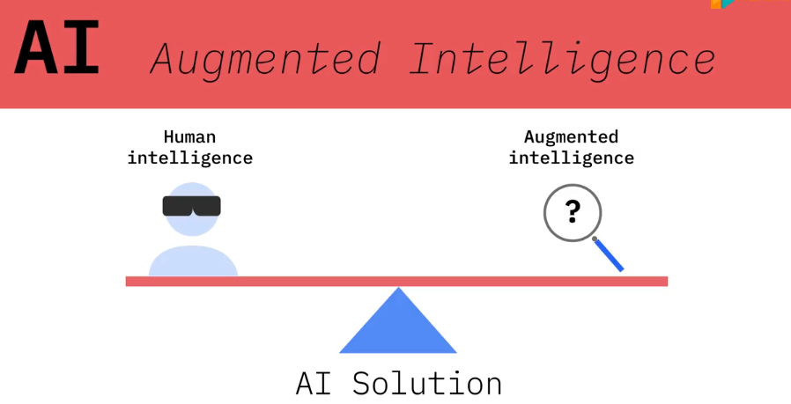

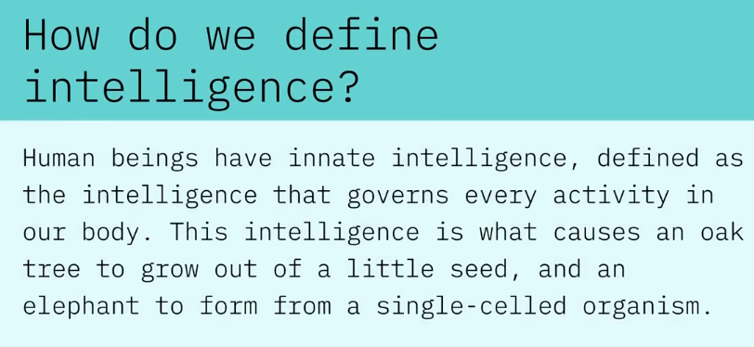

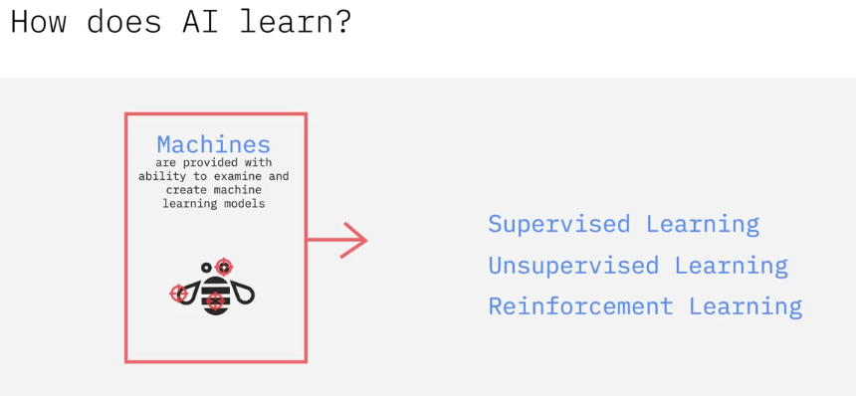

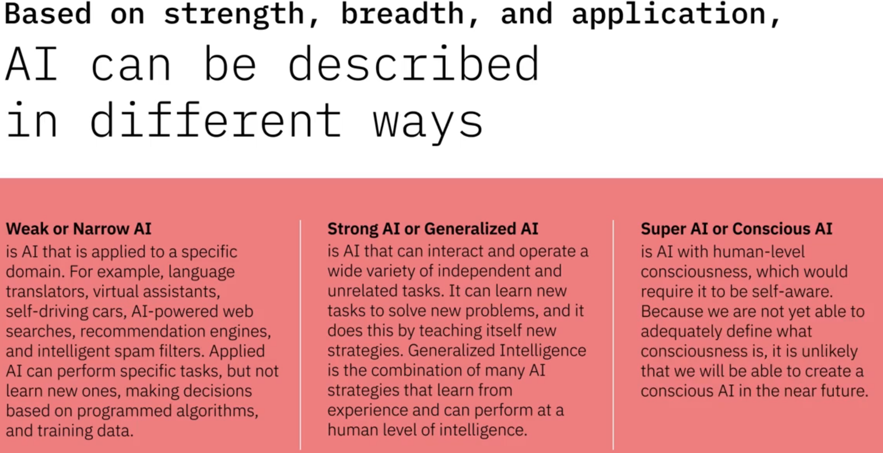

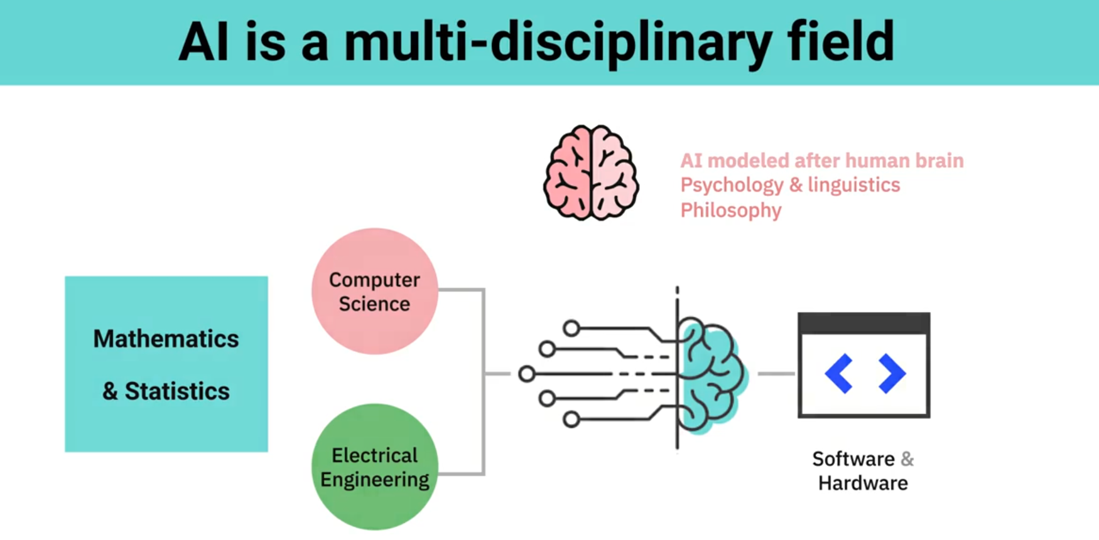

**1.2.2) What is AI**

**Rav Ahuja:**

teaching machines to think like human and act as humans do Creating a technology to replace what people can do the most important thing about Ai is to think and learn on machines

**Johnathan Kelly:**

Ai is the app of computing to solve problems in an intelligent way

**So what is intelligent way?**

Well, an intelligent way may be something that mimics human intelligence. Or it may be a purely computational approach and optimization approach but something that manipulates data in a way to get not obvious results out, I think, is what I would classify as being artificially intelligent.

**Joseph Satarcangelo:**

I would define AI as a tool that uses computer to complete a task automatically with very little to no human intervention.

**Michal Prywata:**

To me is a complex layers of algorithms

**Tanamy Bakshi:**

Artificial intelligence is not the kind of simulating human intelligence that people think it is. It's really not about intelligence at all. B ut I think another word that describes AI more accurately today is machine learning.

**1.2.3) Tanmay’s Journey and Take on AI**

He introduced himself and why he interested in AI and CE

He talked about what is AI he says AI is just machine learning codes which are math algorithms by themselves and people had them and used them in past.

Now with AI we can use machine learning algorithms with better performance

**1.2.4) Generative AI overview and use cases**

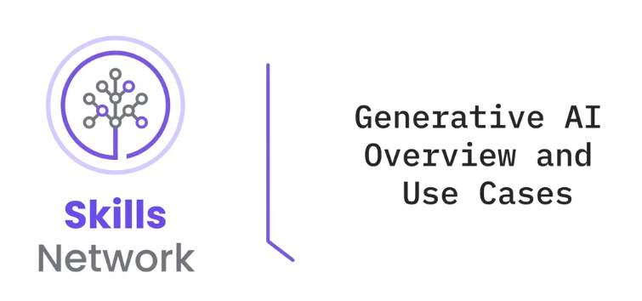

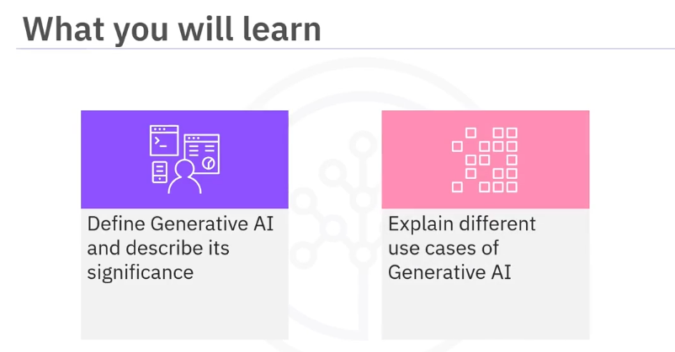

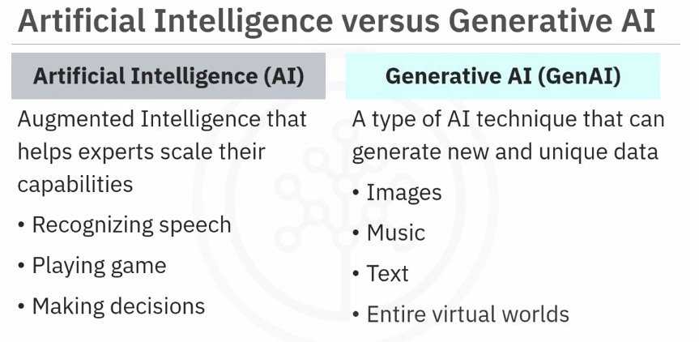

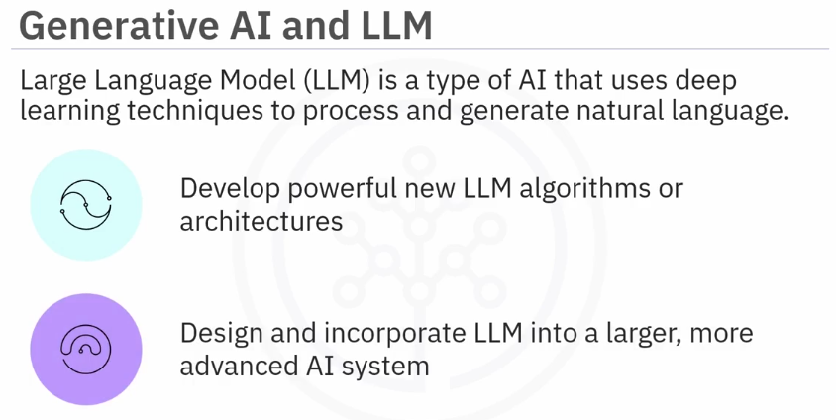

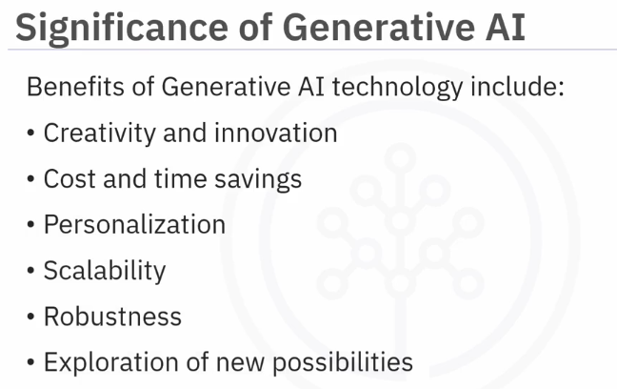

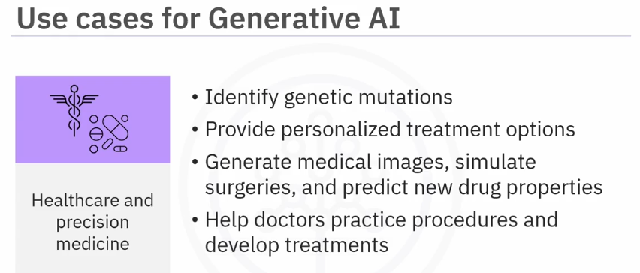

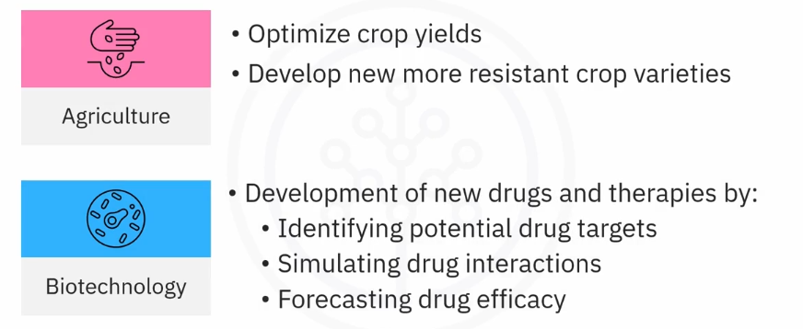

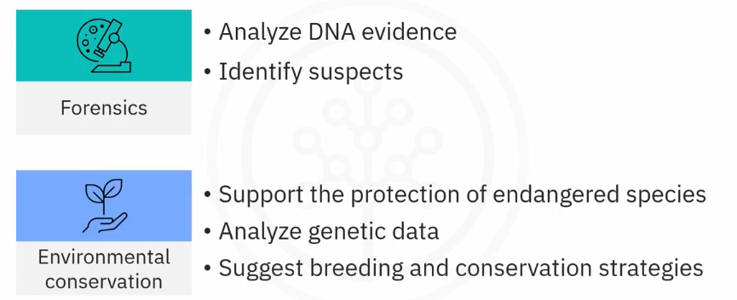

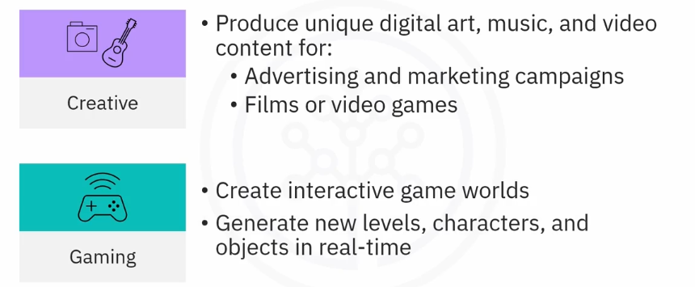

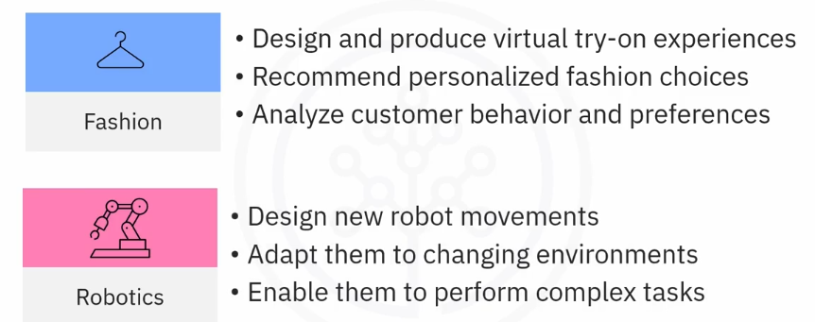

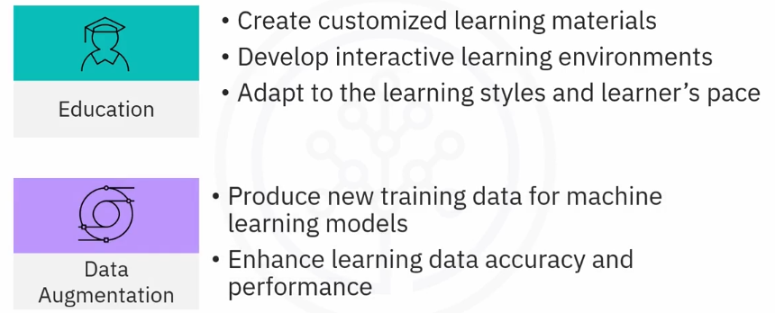

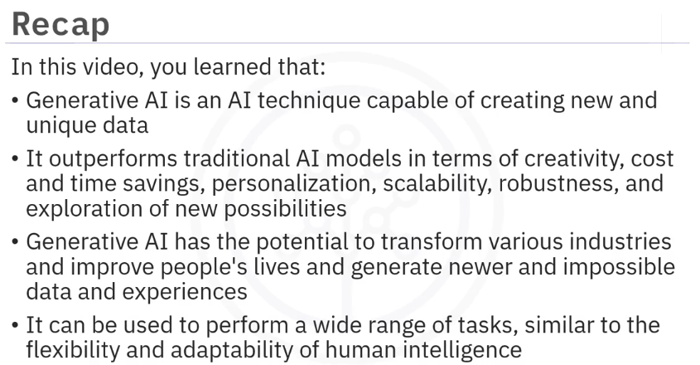

**1.3.1) impact and examples of AI**

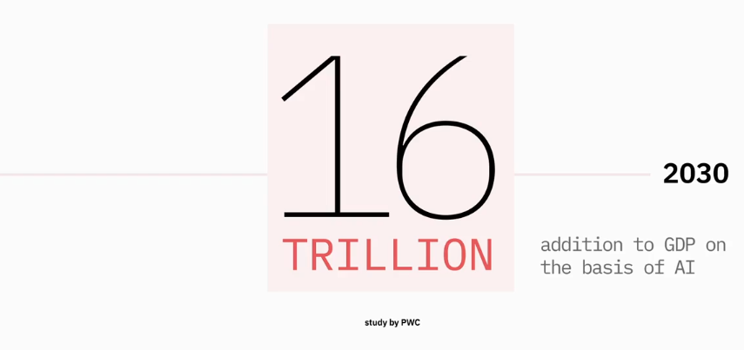

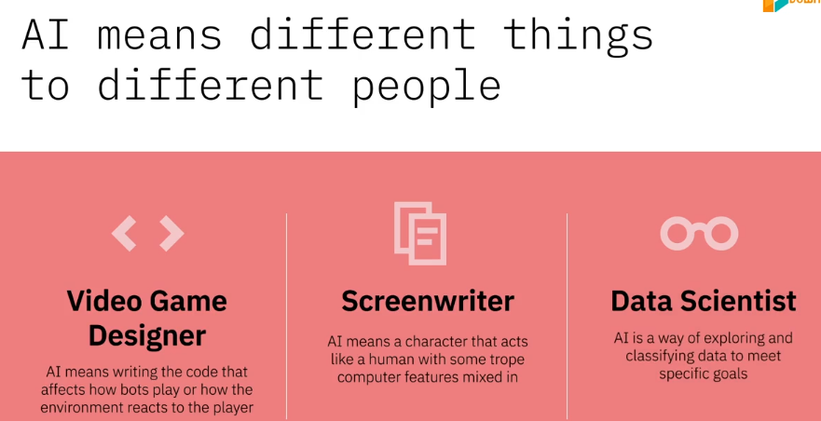

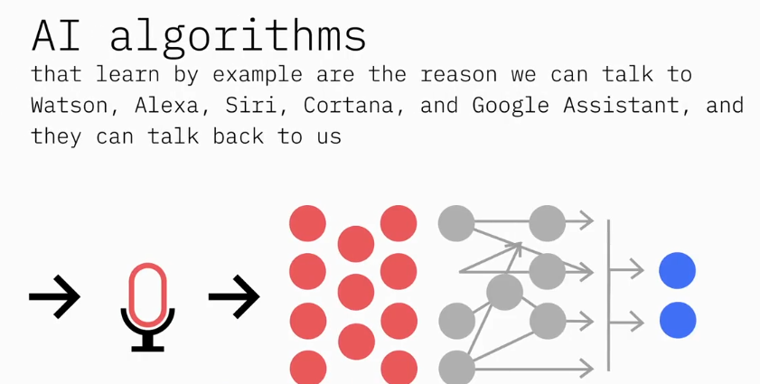

The natural language processing and natural language generation capabilities of AI are not only enabling machines and humans to understand and interact with each other, but are creating new opportunities and new ways of doing business.

**Chatbots:**

Chatbots powered by natural language processing capabilities, are being used in healthcare to question patients and run basic diagnoses like real doctors.

In education providing students to learn conversational interfaces and on demand online tutors.

Customer service chatbots are improving customer experience by resolving queries on the spot and freeing up agent’s time for conversations that add value.

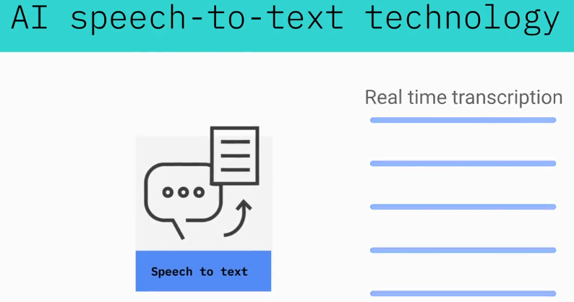

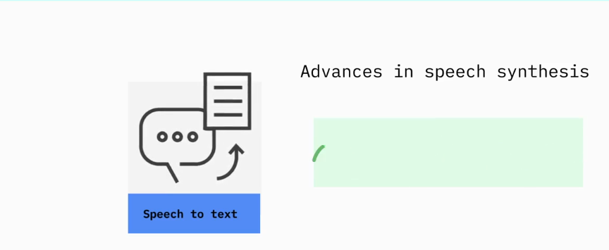

**Computer vision:**

computer vision has been able to surpass humans in tasks related to detecting and labeling objects. Computer vision is one of the reasons why cars can steer their way on streets and highways and avoid hitting obstacles. Computer vision algorithms detect facial features and images and compare them with databases of face profiles. This is what allows consumer devices to authenticate the identities of their owners through facial recognition, social media apps to detect and tag users, and law enforcement agencies to

identify criminals in video feeds

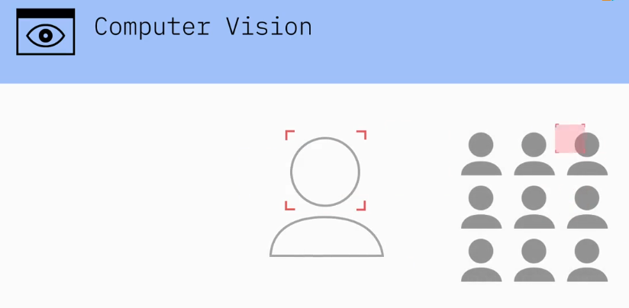

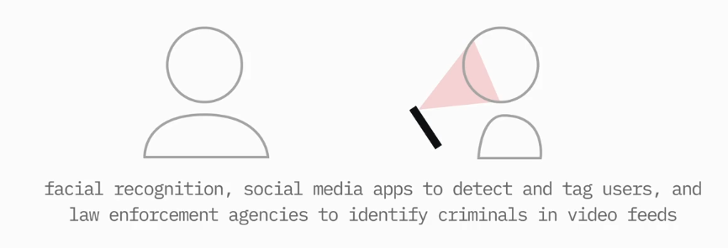

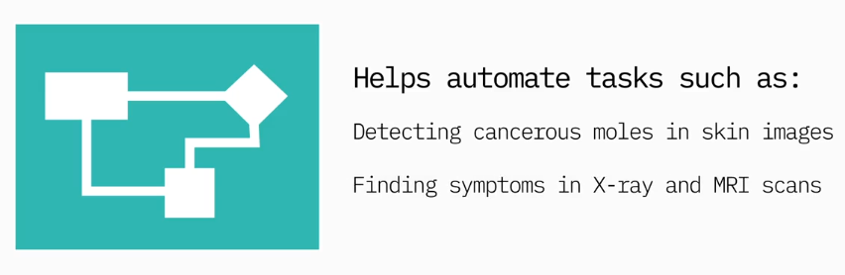

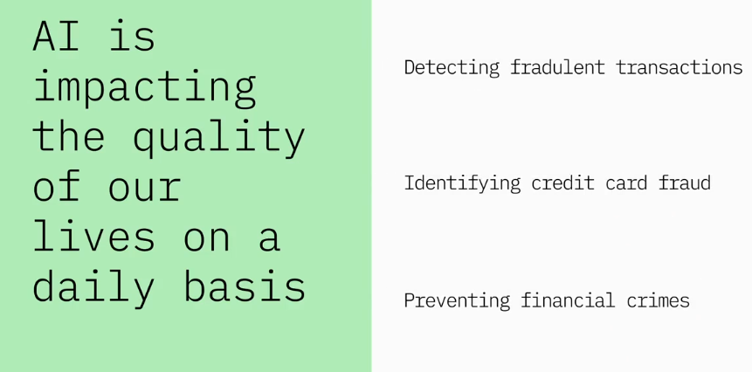

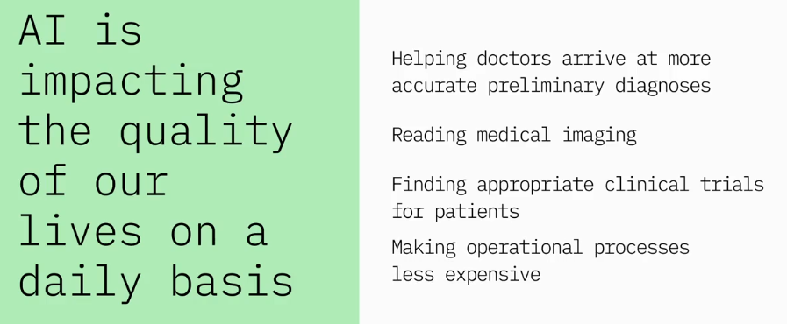

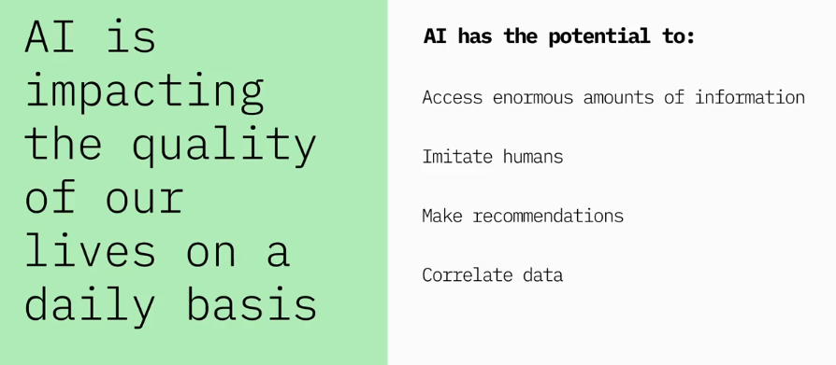

**1.3.2) optional-application-domains-for-ai**

**Question:** can you say some applications of AI?

**Steven Waslander:**

There's all kind of different applications, obviously, there's healthcare, there's finance. The one that's closest to my heart, of course, is robotics and automation. Where the AI technologies really help us to improve our abilities to perceive the environment around the robot and to make plans in unpredictable environments as they're changing.

**Leon Katsnelson:**

There's a great book out by an author, it was Kelvin Kelly, and he is an editor for the Wired magazine, he's written a great book about technologies that are going to be changing shaping our world, specifically 12 technologies. And he's got a fantastic definition in the book about specifically how AI is going to permeate our everyday life and it's all summarized in one excellent quote. So he says that the business cases for the next 10,000 startups are easy to predict, I have x and I will add AI to my x. The way I understand that is it's basically a notion that AI in one shape, way or form, in any shape or form, is going to permeate every aspect of human endeavor. Everything we do, everything we touch is going to be enhanced by AI. We have great benefits from taking any device, any machine, and make it just a little bit smarter. The benefit of that is just adding a bit of smarts to it, a bit of intelligence to it is exponential in its benefit.

**Jonathan Kelly:**

So we work a lot with some really fun applications of AI. We do a couple of different things in the lab that I run. We work on self-driving vehicles as one aspect, so autonomy for self-driving. Which requires a lot of AI for the vision systems, for the navigational intelligence, for the planning and control aspects of the car, we do that. And we also have a large research program in what are called collaborative robotics, or cobots. So robots that are designed to work in and around and with people. And that presents a lot of challenges, because we want the robots to act intelligently and to interface with humans in a way that is natural. And that requires understanding how people behave, which requires intelligence. In addition to those, there are a myriad of other applications, drug discovery, medical treatments for cancer and other diseases. So a bunch of extremely exciting applications.

**Michal Prywata:**

I mean I think the general use of AI so far has been taking large data sets, and making sense of them. And doing some sort of processing with that data in real time. That's what we've been doing, and that's what we've seen most effective, in terms of creating some sort of larger scale impact in healthcare beyond just having a siloed device. And we've been seeing that across the board, across the whole healthcare spectrum

**Joseph Satarcangelo:**

We use AI all the time, and a lot of the times we're not even aware of it. We use AI every time we type in a search query on a search engine, every time we use our GPS. Or every time we use some kind of voice recognition system.

**Polong Lin:**

I like to focus on a particular segment of AI, if that's okay, around computer vision. Because it's just particularly fascinating to me. Now, when we think of computer vision, they're looking at AI in ways to help augment, or to help automate or to help train computers to do something that's already very difficult to train humans to do. Like when it comes to the airport, trying to find weapons within luggage through the X-ray scanner, now that could be difficult to do. No matter how much you train someone that can be very difficult to identify. But with computer vision that can help to automate, help to augment, help to flag, certain X-ray images so that maybe even humans can just take a look at a filtered set of images, not all of the images right? So computer vision is very disruptive. And so there's many ways in which computer vision can really help to augment the capabilities of humans in lots of different industries.

**Tanmay Bakshi:**

Now I mean applications of AI are really all around us. There's no limit to really what we're doing with artificial intelligence. When you do practically anything on any technology, you're most probably using some form of what we call machine learning or artificial intelligence. For example, when you check your email. Doing something as simple as checking your email. Spam filtering has been done for years with machine learning technology. More recently, Google came out with their features that enable you to do smart email compositions. So you can actually have text written for you on the fly as you're writing your email. Your subjects are automatically written as well, it'll recommend to you who you should be sending the email to, see if you missed someone. All of these things are powered by machine learning. But some of the main areas where I believe machine learning technology can make an impact are the fields of health care and education.

**1.3.4) more applications of AI**

**Question:** can you talk about AI in action?

**Tanamy Bakshi:**

To give an example of say machine learning in action today, how companies have actually implemented it, there's one example that always love to go back to, and it is the example of Woodside Energy, a company in the Australia New Zealand region. Now originally, they actually contacted IBM because they wanted the IBM to be able to create essentially a system that can understand the different documents and the research that they're engineers come up with, and have Watson and understand that, and essentially replace some of the engineers on their team. IBM actually went ahead and build the application that worked to Watson was able to understand that unstructured content, but they never ended up replacing any of their engineers. Instead, they actually ended up hiring more engineers, because now they realized that two things. First of all, the barrier of entry for each engineer is now lower and knowledge can now be shared more effectively among the teams. Because now instead of research being written and put into an archive drawer where it's never seen again, Watson's ingesting that data, understanding it and providing it to whoever needs it, whoever Watson thinks would need that data.

Polong Lin:

So if you imagine in these TV shows and in these movie scenes as well, you have sometimes, if someone's looking for a particular suspect in this particular traffic intersection or whatnot, if passed through this intersection, and there's of course some cameras around. So we have the security guard maybe, trying to look through hours and hours, dozens and hundreds of hours of footage, maybe at 10x speed and find that particular black SUV or that green car. Then as soon as they find it at the end of the episode or whatnot, then say aha, we found that person. But if you had some sort of computer vision algorithm running on this video for just the entire time, then you wouldn't have a need for some person to have to manually watch through hours and hours of footage.

**Michal Prywata:** Our specific use case is actually triggering new neural pathways in the brain to form. As you can imagine, there's a lot of information that happens there between the connection of how your body functions andhow your brain functions, and what parts ofthe brain are damage, what parts of the brainaren't damaged, and how you're actually movingthe person or how you're triggering certain thingsin the human body to happen in order fornew neural pathways to form. So what we've done is actually, we've created massive data sets of information ofhow people move, and how that responds todifferent areas of the brain. Through that information,we're able to trigger specific movementswith a robotic device, which in turn creates these neural pathwaysto form in the brain, and therefore recovering the person who suffered a neurological trauma.

**1.3.3) Applications of AI (with interviewer)**

**Question:** Can you give Can you give some specific examples of applications of AI?

**Johnathan Kelly:** Certainly. So we have a fairly large collaborative robotics program. So the cobots we work on are primarily targeted at the moment at manufacturing applications, manufacturing, warehousing, logistics, these types of applications where normally you may have a person doing a job that can be dull, it can be dangerous, and having robotic support or having a robot actually do the job may make it much safer, more efficient, and more effective overall. So we work on a lot of those types of applications, particularly where the robots are trying to interface directly with people, as I said. So the robot may help an individual to lift a heavy container, or help to move items on a stocking, on a shelf stocking purposes, so all these kinds of applications, where I think we'll see collaborative robots move first, and then hopefully one day and maybe into your home to help you with the laundry and dishes in the kitchen.

**Polong Lin:** Hopefully. For example, in oil and gas, there's a company, a pretty large oil and gas company called the Abu Dhabi National Oil Company, and one of the problems that any kind of oil company has to deal with is, where's the best place for them to drill for oil? So they have to find these rock samples of all these different places, for this place and in this place, and that place, and maybe hundreds of different places for them to drill oil. From these rock samples, now you have all these fine sheets of rock in maybe hundreds or thousands of them, and it's up to these oil companies to be able to classify these using they're trained and expert geologists. But to train geologists to properly classify these sheets of rock can be quite difficult, it could be time-consuming, could cost a lot of money as well. So one way to help augment the capabilities of humans is to be able to use computer vision, to classify these rocks samples to be able to identify which of these locations are the best to drill for oil? That's in oil and gas.

**Tanamy Bakshi:** Imagine before this,if there was a very, very rare form of cancer experienced by a doctor in Dubai, and if there were another case in New Zealand, how do you think they would have actually figured out that, "Hey, we're both dealing with this very rare case since we work together." That wouldn't have been possible in the past, but now with machine learning technology being able to aggregate knowledge from so many different sources into one centralized Cloud and understand it, and provide that information inaccessible, intuitive, implicit way. Now, that New Zealand doctor can actually go ahead and use this machine learning technique to say, "Hey, just a few days ago there was a doctor with a very similar case," even though it may not be the exact same thing.

**1.3.4) SOME MORE APPLICATIONS OF AI**

**SKIPPED**

**1.3.5) famous applications of AI from IBM**

It was about using AI in Grammy festival recording or using it in sports for Espn or analyzing the game. Also used in medical.

* Watson playing Jeopardy to win against two of its greatest champions, Ken Jennings and Brad Rutter.
* Watson teaming up with the Academy to deliver an amplified Grammy experience for millions of fans.
* Watson collaborating with ESPN to serve 10 million users of the ESPN Fantasy App sharing insights that help them make better decisions to win their weekly matchups.

**1.3.6) generative AI applications**

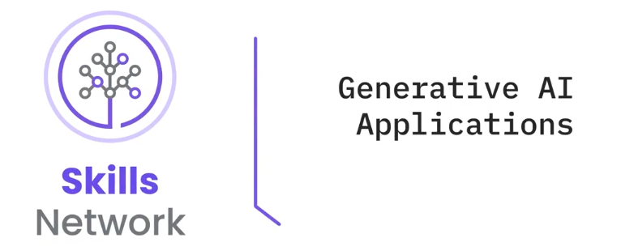

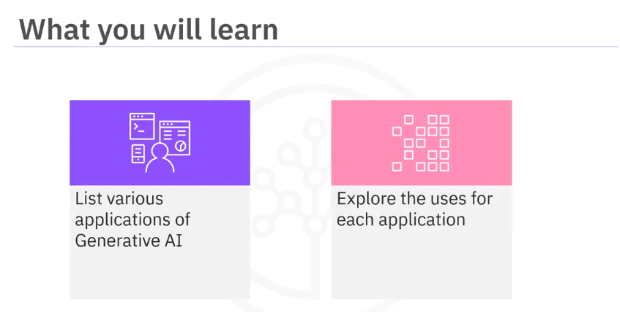

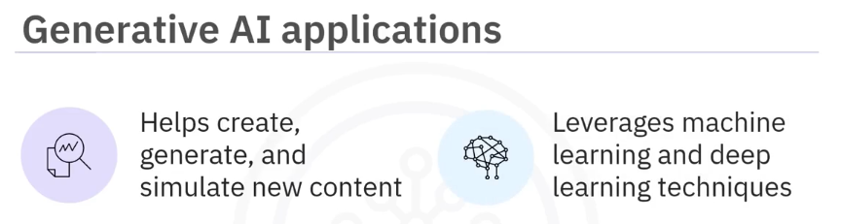



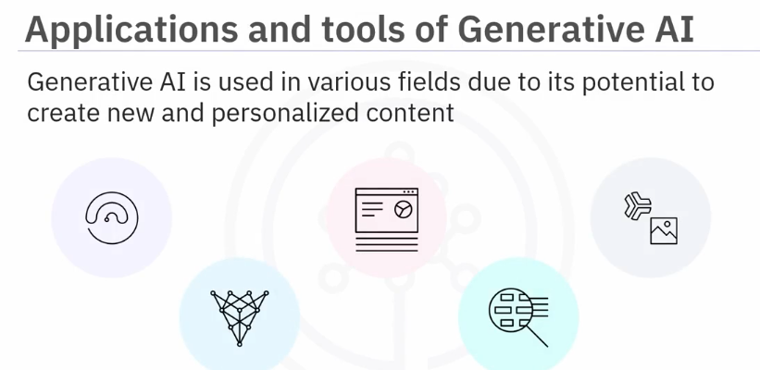

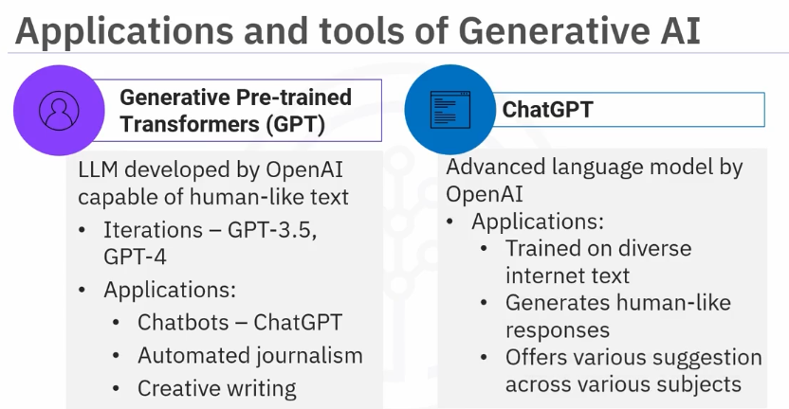

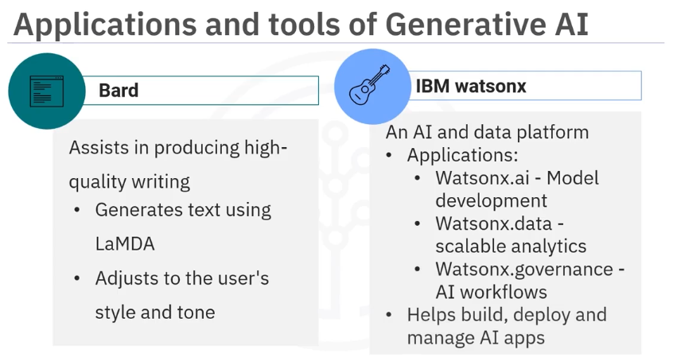

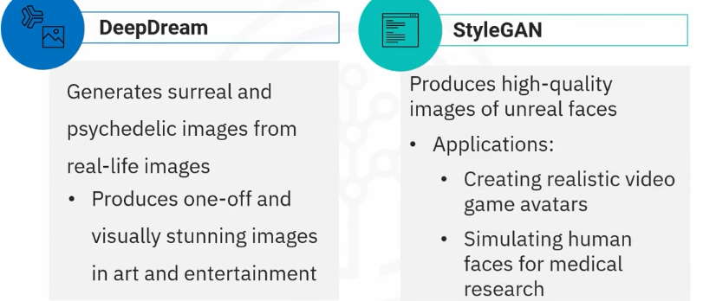

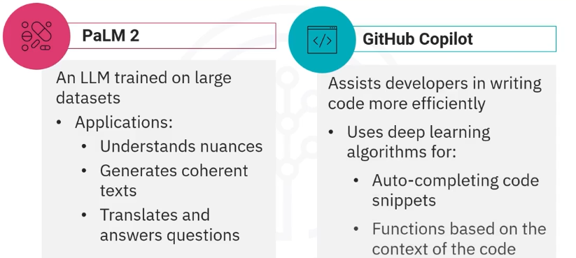

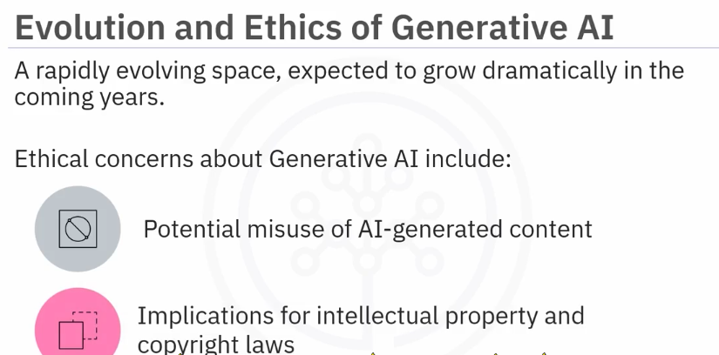

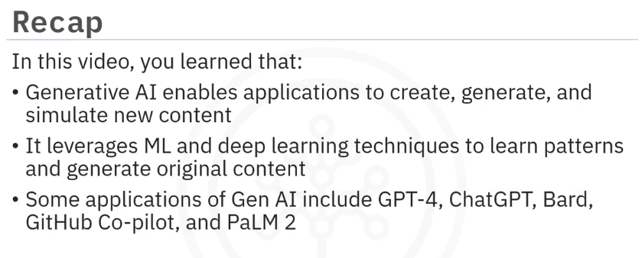

**Part 2) ai-concepts terminology and application-areas**

**2.1.1)** **cognitive-computing-perception-learning-reasoning**

AI is at the forefront of a new era of computing, Cognitive Computing. It’s very different from programming system. It solves the problem like human does. When we as humans seek to understand something and to make a decision, we go through four key steps. First, we observe visible phenomena and bodies of evidence. Second, we draw on what we know to interpret what we are seeing to generate hypotheses about what it means. Third, we evaluate which hypotheses are right or wrong. Finally, we decide, choosing the option that seems best and acting accordingly. Just as humans become experts by going through the process of observation, evaluation, and decision-making, cognitive systems use similar processes to reason about the information they read, and they can do this at massive speed and scale. Unlike conventional computing solutions, which can only handle neatly organized structured data such as what is stored in a database, cognitive computing solutions can understand unstructured data, which is 80 percent of data today. All of the information that is produced primarily by humans for other humans to consume. This includes everything from literature, articles, research reports to blogs, posts, and tweets. While structured data is governed by well-defined fields that contain well-specified information, cognitive systems rely on natural language, which is governed by rules of grammar, context, and culture. It is implicit, ambiguous, complex, and a challenge to process. While all human language is difficult to parse, certain idioms can be particularly challenging. In English for instance, we can feel blue because it's raining cats and dogs, while we're filling in a form, someone asked us to fill out. Cognitive systems read and interpret text like a person. They do this by breaking down a sentence grammatically, relationally, and structurally, discerning meaning from the semantics of the written material. Cognitive systems understand context. This is very different from simple speech recognition, which is how a computer translates human speech into a set of words. Cognitive systems try to understand the real intent of the user’s language, and use that understanding to draw inferences through a broad array of linguistic models and algorithms. Cognitive systems learn, adapt, and keep getting smarter. They do this by learning from their interactions with us, and from their own successes and failures, just like humans do.

**2.2.1)** **terminology-and-related-concepts**

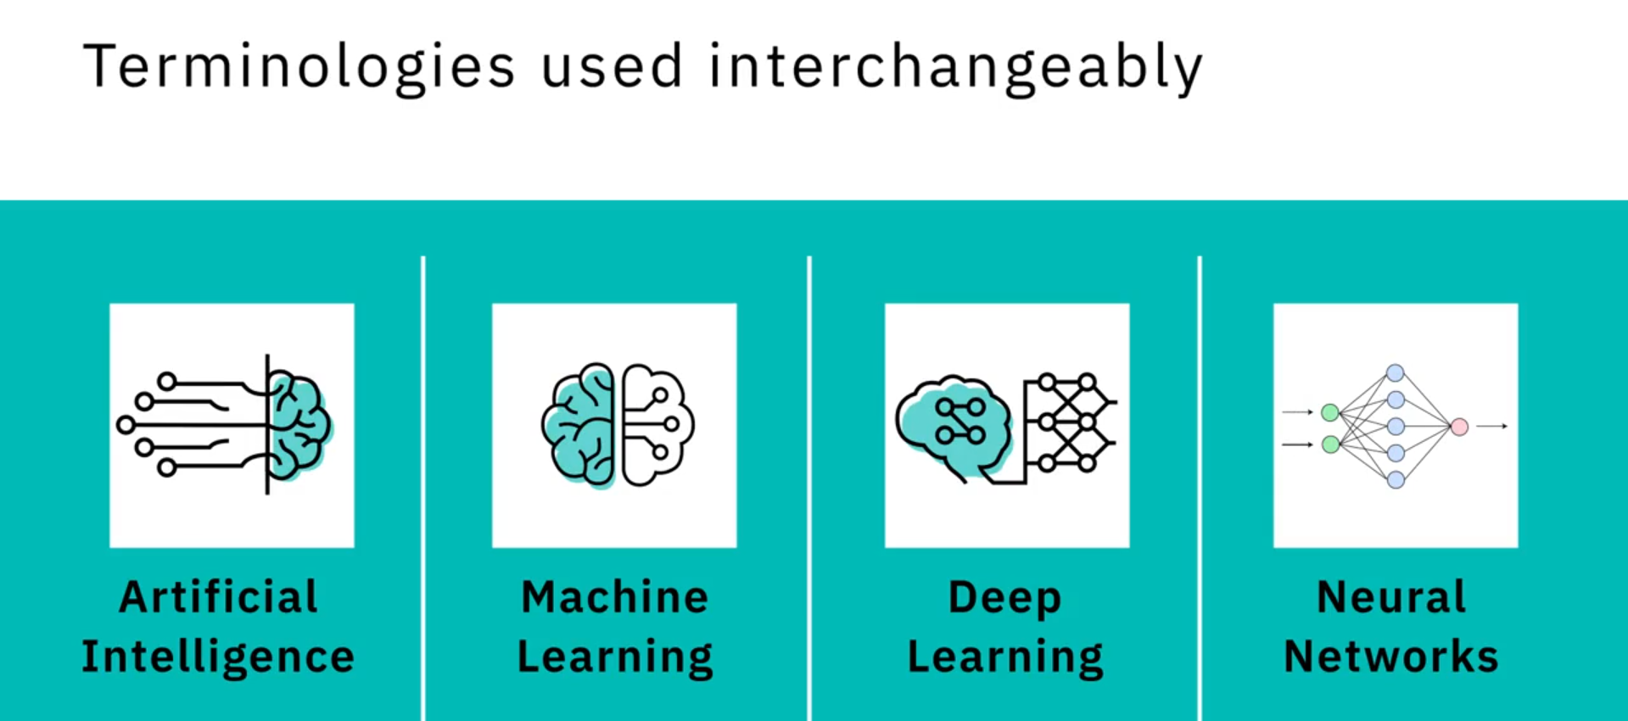

These terms are sometimes used interchangeably, but they do not refer to the same thing.

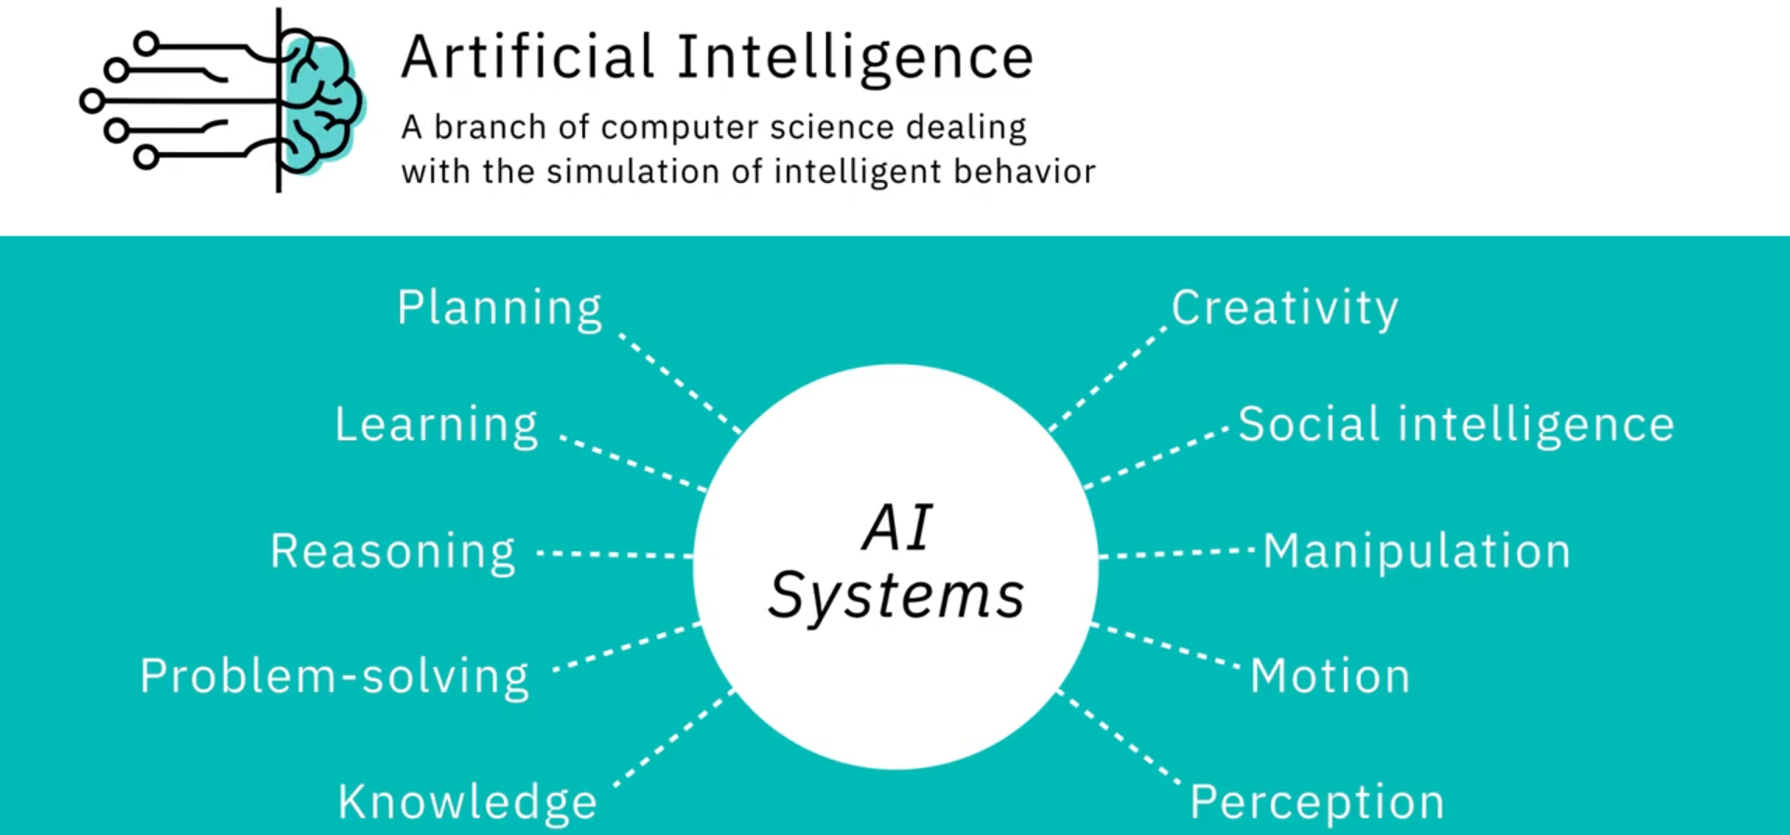

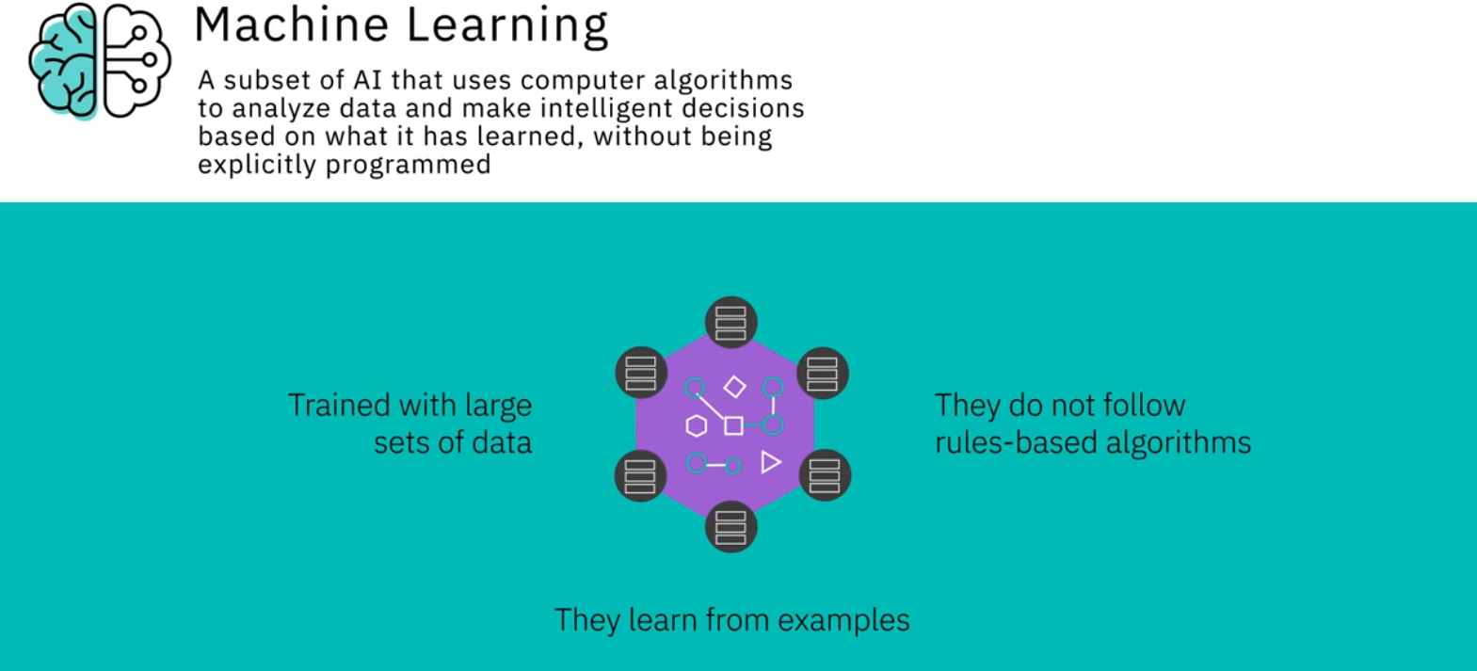

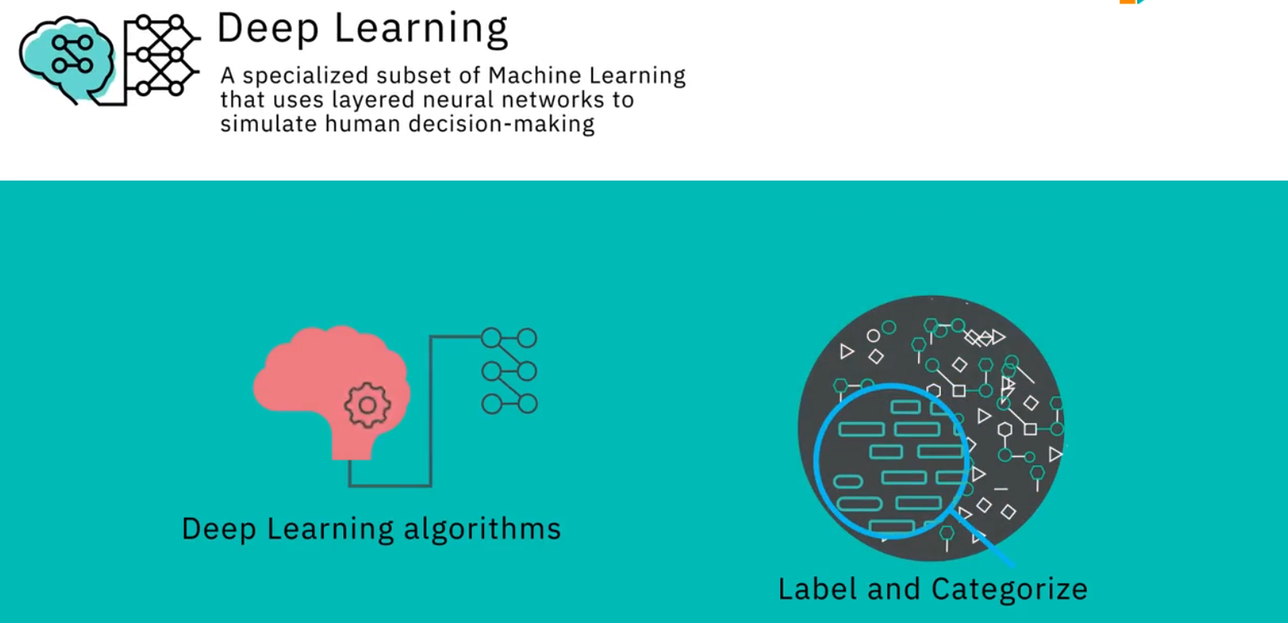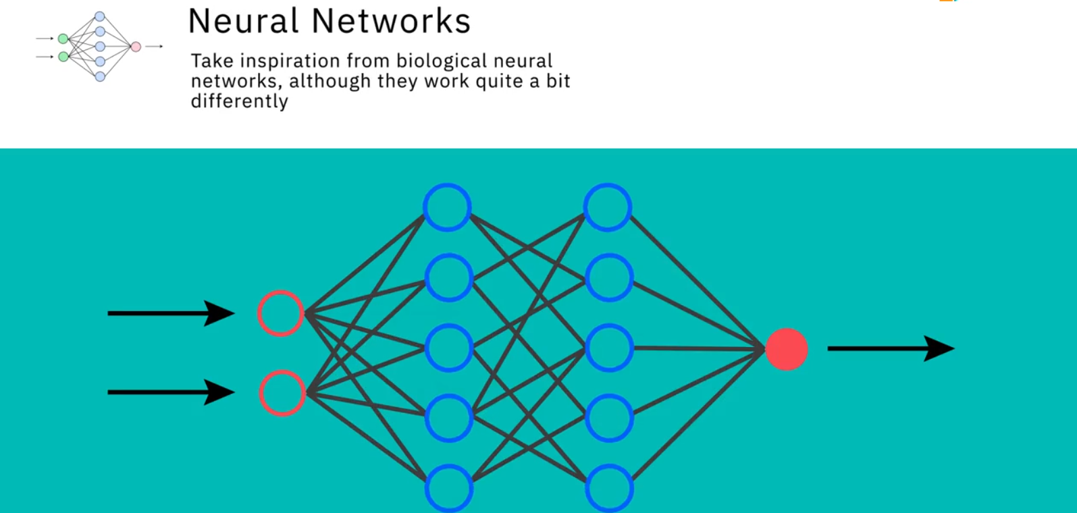

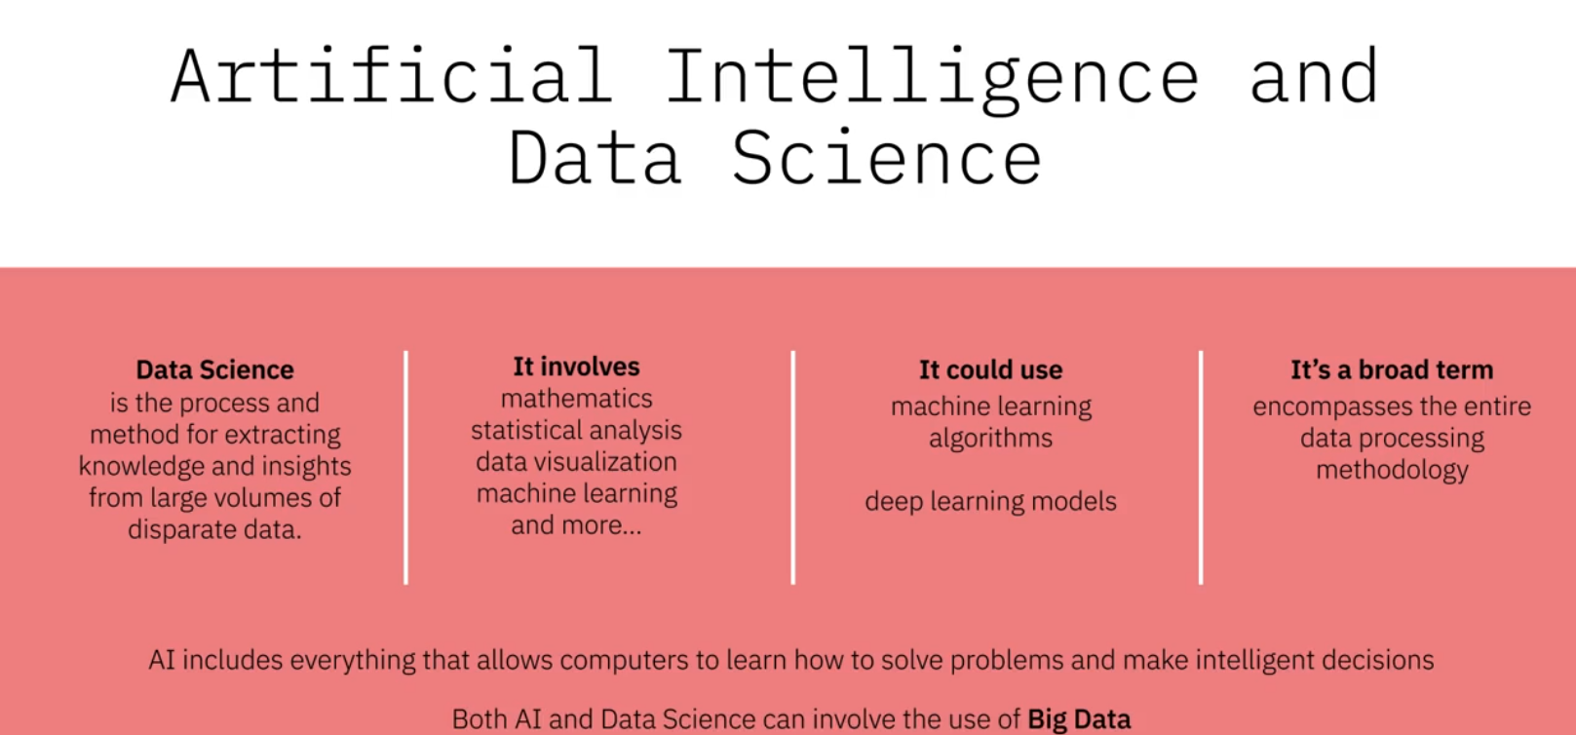

**2.2.2) machine learning**

Machine learning is a subset of AI witch use algorithms to analyze data and make intelligent decisions based on what it has learned.

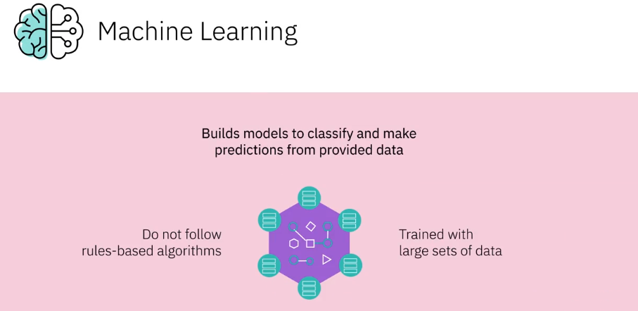

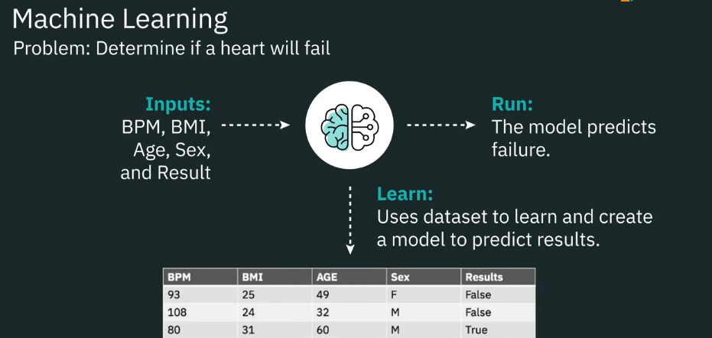

**Difference between traditional programming and machine learning:**

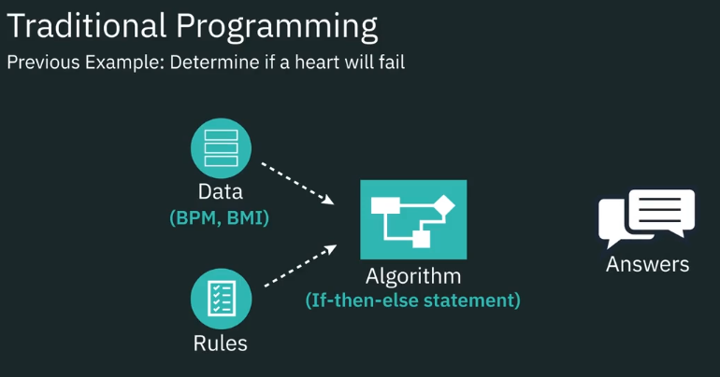  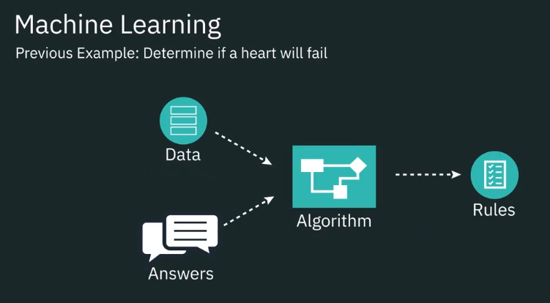

What the model do in ML do is determine what parameters are in traditional programming.

**\*\*Machine Learning relies on defining behavioral rules by examining and comparing large datasets to find common patterns.**

**Different machine language types:**

